**TICKET BOOKING SYSTEM**

You are tasked with creating a ticket booking system for a Event. The system should support booking tickets for different types of events, such as movies, concerts, and plays. Each event has its own pricing strategy, and the system should also track available seats and customer bookings.

**Database Tables:**

1. Venue Table

* venue_id (Primary Key)
* venue_name
* address

2. Event Table

* event_id (Primary Key)
* event_name,
* event_date DATE
* event_time TIME,
* venue_id (Foreign Key)
* total_seats
* available_seats
* ticket_price DECIMAL
* event_type ('Movie', 'Sports', 'Concert')
* booking_id (Foreign Key)

3. Customer Table

* customer_id (Primary key)
* customer_name
* email
* phone_number
* booking_id (Foreign Key)

4. Booking Table

* booking_id (Primary Key)
* customer_id (Foreign Key)
* event_id (Foreign Key)
* num_tickets
* total_cost
* booking_date

**Tasks 1: Database Design:**

1. Create the database named "**TicketBookingSystem**"

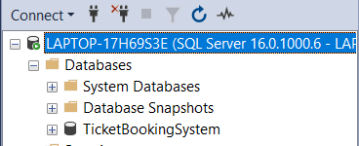

**Image 1.1 Database Creation**

**Query:** CREATE DATABASE TicketBookingSystem

2. Write SQL scripts to create the mentioned tables with appropriate data types, constraints

* **Venue**

Query: CREATE TABLE Venue (

venue_id INT PRIMARY KEY IDENTITY,

venue_name VARCHAR(100) NOT NULL,

address VARCHAR(255) NOT NULL

)

* **Booking**

Query: CREATE TABLE Booking (

booking_id INT PRIMARY KEY IDENTITY,

customer_id INT NOT NULL,

event_id INT NOT NULL,

num_tickets INT NOT NULL,

total_cost DECIMAL(10, 2) NOT NULL,

booking_date DATE NOT NULL

)

* **Customers**

Query : CREATE TABLE Customer(

customer_id INT PRIMARY KEY IDENTITY,

customer_name VARCHAR(100) NOT NULL,

email VARCHAR(100) NOT NULL,

phone_number VARCHAR(20) NOT NULL,

booking_id INT

)

* **Event**

Query: CREATE TABLE Event (

event_id INT PRIMARY KEY IDENTITY,

event_name VARCHAR(100) NOT NULL,

event_date DATE NOT NULL,

event_time TIME NOT NULL,

venue_id INT NOT NULL,

total_seats INT NOT NULL,

available_seats INT NOT NULL,

ticket_price DECIMAL(10, 2) NOT NULL,

event_type VARCHAR(50) NOT NULL,

booking_id INT)

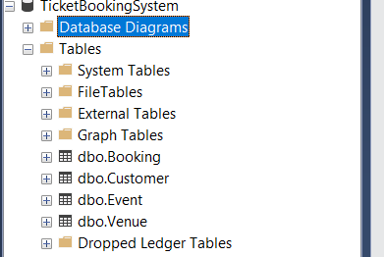

**Image 1.2 Table Creation**

3. Create an ERD (Entity Relationship Diagram) for the database.

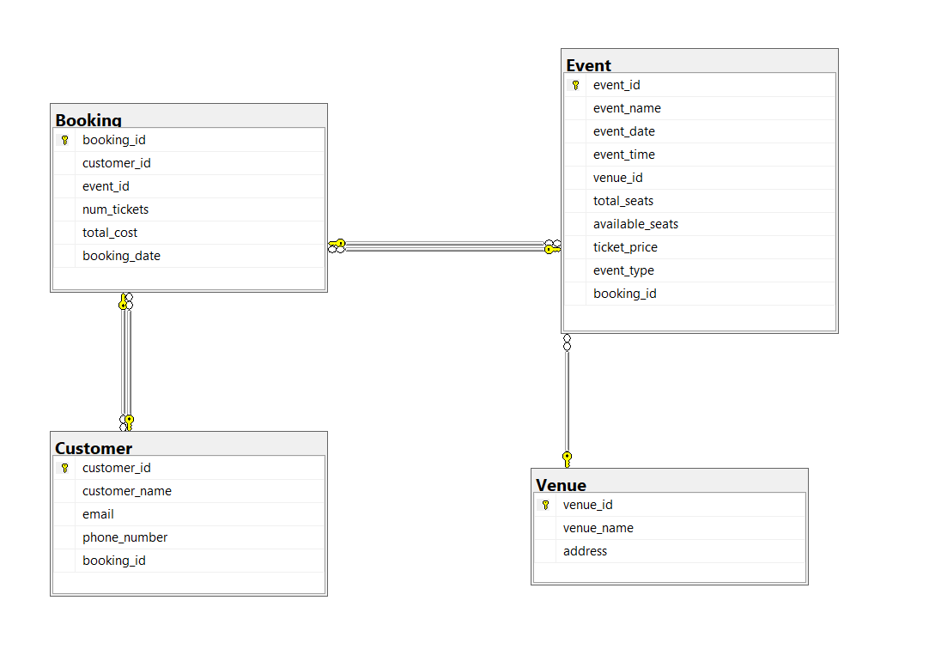

**Image 1.3 Entity-Relationship Diagram**

4. Create appropriate Primary Key and Foreign Key constraints for referential integrity.

**--For Event Table:**

ALTER TABLE Event

ADD CONSTRAINT FK_Event_Venue FOREIGN KEY (venue_id) REFERENCES Venue(venue_id),

CONSTRAINT FK_Event_Booking FOREIGN KEY (booking_id) REFERENCES Booking(booking_id)

**--For Customer Table:**

ALTER TABLE Customer

ADD CONSTRAINT FK_Customer_Booking FOREIGN KEY (booking_id) REFERENCES Booking(booking_id)

**--For Booking Table:**

ALTER TABLE Booking

ADD CONSTRAINT FK_Booking_Customer FOREIGN KEY (customer_id) REFERENCES Customer(customer_id),

CONSTRAINT FK_Booking_Event FOREIGN KEY (event_id) REFERENCES Event(event_id)

**--Using check constraint we can allow specific values :**

ALTER TABLE Event

ADD CONSTRAINT CK_Event_EventType CHECK (event_type IN ('Movie', 'Sports', 'Concert'))

**Tasks 2: Select, Where, Between, AND, LIKE:**

1. Write a SQL query to insert at least 10 sample records into each table

Inserting values into tables using ‘INSERT’ along with its columns and respected values

-- Inserting data into Venue Table:

INSERT INTO Venue (venue_name, address)

VALUES('Heavenly Palace', ' Walajah Road, Near T Nagar Bus Stand, Chennai, Tamil Nadu 600017')

INSERT INTO Venue (venue_name, address)

VALUES

('Paradise Gardens', 'SIDCO Industrial Estate, Vandalur Road, Chennai, Tamil Nadu 600127'),

('Atlantis', 'Besant Nagar, Chennai, Tamil Nadu 600014'),

('The Blue Fin', 'Chepauk, Chennai, Tamil Nadu 600001'),

('The Greenhouse', '1, Mount Road, Guindy, Chennai, Tamil Nadu 600032'),

('Lotus Lakes', 'Dr. Radhakrishnan Salai, Saidapet, Chennai, Tamil Nadu 600035'),

('The Golden Plaza', 'Mount Road, Opposite Fort St. George, Chennai, Tamil Nadu 600001'),

('Prime Lands', 'Luz Corner, Luz, Mylapore, Chennai, Tamil Nadu 600004'),

('La Parisienne', 'Parrys Corner, Near High Court, Chennai, Tamil Nadu 600001.'),

('Harbor Town', 'Injambakkam, Kelambakkam Road, Chennai, Tamil Nadu 600127.')

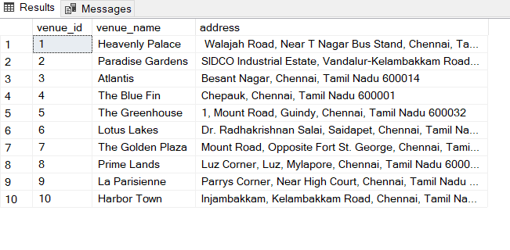

**Image 2.1 Venue Table**

-- Inserting data into Event Table:

INSERT INTO Event (event_name, event_date, event_time, venue_id, total_seats, available_seats, ticket_price, event_type)

VALUES

('Event 1', '2024-04-01', '10:00', 1, 100, 100, 150.00, 'Movie'),

('Event 2', '2024-04-03', '11:00', 2, 150, 150, 1600.00, 'Sports'),

('Event 3', '2024-04-03', '12:00', 3, 200, 200, 700.00, 'Concert'),

('Event 4', '2024-04-06', '13:00', 1, 120, 120, 200.00, 'Movie'),

('Event 5', '2024-04-07', '14:00', 6, 180, 180, 650.00, 'Sports'),

('Event 6', '2024-04-07', '15:00', 6, 220, 220, 750.00, 'Concert'),

('Event 7', '2024-04-07', '16:00', 10, 130, 130, 580.00, 'Movie'),

('Event 8', '2024-04-10', '17:00', 8, 190, 190, 689.00, 'Sports'),

('Event 9', '2024-04-12', '18:00', 9, 230, 230, 788.00, 'Concert'),

('Event 10', '2024-04-20', '19:00', 10, 140, 140, 160.00, 'Movie')

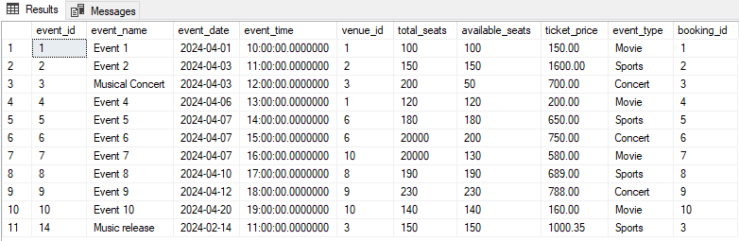

**Image 2.2 Event Table**

-- Inserting data into Customer Table:

INSERT INTO Customer (customer_name, email, phone_number)

VALUES

('Priya Sharma', 'priya.sharma@gmail.com', '9876543210'),

('Rahul Patel', 'rahul.patel@gmail.com', '8765432109'),

('Neha Singh', 'neha.singh@gmail.com', '7654321098'),

('Rohit Kumar', 'rohit.kumar@gmail.com', '6543210987'),

('Meera Gupta', 'meera.gupta@gmail.com', '9432109876'),

('Aryan Khan', 'aryan.khan@gmail.com', '9321098765'),

('Anjali Nair', 'anjali.nair@gmail.com', '9210987654'),

('Vikram Singh', 'vikram.singh@gmail.com', '9109876543'),

('Riya Sen', 'riya.sen@gmail.com', '9098765432'),

('Mohammed Hussain', 'md.hussain@gmail.com', '9987654321')

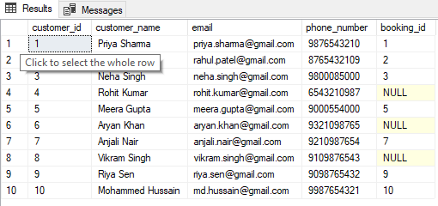

**Image 2.3 Customer Table**

--Inserting data into Booking Table:

INSERT INTO Booking (customer_id, event_id, num_tickets, total_cost, booking_date)

VALUES

(1, 1, 2, 100.00, '2024-02-28'),

(2, 2, 3, 180.00, '2024-02-29'),

(3, 3, 1, 70.00, '2024-03-01'),

(4, 4, 4, 220.00, '2024-03-02'),

(5, 5, 2, 130.00, '2024-03-03'),

(6, 6, 3, 225.00, '2024-03-04'),

(7, 7, 1, 58.00, '2024-03-05'),

(8, 8, 2, 136.00, '2024-03-06'),

(9, 9, 3, 234.00, '2024-03-07'),

(10, 10, 1, 60.00, '2024-03-08')

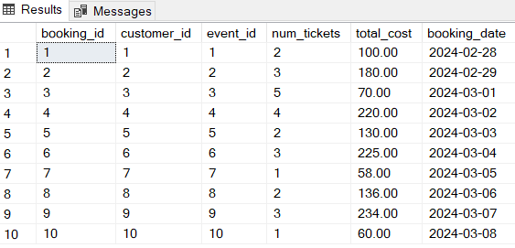

**Image 2.4 Customer Table**

2. Write a SQL query to list all Events

**Query:** SELECT * FROM Event

3. Write a SQL query to select events with available tickets.

**Query:** SELECT * FROM Event WHERE available_seats > 0

4. Write a SQL query to select events name partial match with ‘cup’.

**Query:** SELECT * FROM Event WHERE event_name LIKE '%cup%'

5. Write a SQL query to select events with ticket price range is between 1000 to 2500.

**Query:** SELECT * FROM Event WHERE ticket_price BETWEEN 1000 AND 2500

6. Write a SQL query to retrieve events with dates falling within a specific range.

**Query:** SELECT * FROM Event WHERE event_date BETWEEN '2024-04-03' AND '2024-04-10'

7. Write a SQL query to retrieve events with available tickets that also have "Concert" in their name.

**Query:** SELECT * FROM Event WHERE available_seats > 0 AND event_name LIKE '%Concert%'

8. Write a SQL query to retrieve users in batches of 5, starting from the 6th user.

**Query:** SELECT *

FROM Customer

ORDER BY customer_id

OFFSET 5 ROWS FETCH NEXT 5 ROWS ONLY

9. Write a SQL query to retrieve bookings details contains booked no of ticket more than 4.

**Query:** SELECT * FROM Booking WHERE num_tickets > 4

10. Write a SQL query to retrieve customer information whose phone number end with ‘000’

**Query:** SELECT * FROM Customer WHERE RIGHT(phone_number, 3) = '000'

11. Write a SQL query to retrieve the events in order whose seat capacity more than 15000.

**Query:** SELECT * FROM Event WHERE total_seats > 15000

12. Write a SQL query to select events name not start with ‘x’, ‘y’, ‘z’.

**Query:** SELECT event_name

FROM Event

WHERE LEFT(event_name, 1) != 'x'

AND LEFT(event_name, 1) != 'y'

AND LEFT(event_name, 1) != 'z'

**Task 3. Aggregate functions, Having, Order By, GroupBy and Joins**

1. Write a SQL query to List Events and Their Average Ticket Prices.

**Query:** SELECT event_id, event_name, AVG(ticket_price) AS average_price

FROM Event

GROUP BY event_id, event_name

2. Write a SQL query to Calculate the Total Revenue Generated by Events.

**Query:** SELECT SUM(total_seats * ticket_price) AS total_revenue

FROM Event;

SELECT * FROM Customer

3. Write a SQL query to find the event with the highest ticket sales.

**Query:** SELECT TOP 1 *, (total_seats-available_seats) AS Tickets_Sold

FROM Event

ORDER BY (total_seats-available_seats) Desc

SELECT * FROM Event

4. Write a SQL query to Calculate the Total Number of Tickets Sold for Each Event.

**Query:** SELECT *, (total_seats-available_seats) AS [Tickets Sold]

FROM Event

UPDATE Event

SET available_seats = 50

WHERE event_id = 3

5. Write a SQL query to Find Events with No Ticket Sales.

**Query:** SELECT *, (total_seats-available_seats) AS [Tickets Sold]

FROM Event

WHERE (total_seats-available_seats) = 0

6. Write a SQL query to Find the User Who Has Booked the Most Tickets.

**Query:**SELECT * FROM Booking

ORDER BY num_tickets DESC

OR

**Query:** SELECT TOP 1 customer_id, num_tickets

FROM Booking

ORDER BY num_tickets DESC

7. Write a SQL query to List Events and the total number of tickets sold for each month

**Query:** SELECT

YEAR(event_date) AS [Booking Year],

DATENAME(MONTH, event_date) AS [Booking Month],

event_id,

event_name,

(total_seats-available_seats) AS [Tickets Sold]

FROM Event

GROUP BY

YEAR(event_date),

DATENAME(MONTH, event_date),

event_id, event_name, (total_seats-available_seats)

ORDER BY [Booking Year],[Booking Month]

8. Write a SQL query to calculate the average Ticket Price for Events in Each Venue.

**Query:** SELECT

v.venue_id,

v.venue_id,

AVG(e.ticket_price) AS [Average Ticket Price]

FROM VENUE AS v

JOIN Event AS e ON v.venue_id = e.venue_id

GROUP BY V.venue_id, E.event_id

9. Write a SQL query to calculate the total Number of Tickets Sold for Each Event Type

**Query:** SELECT

e.event_type,

SUM(b.num_tickets) AS total_tickets_sold

FROM Event e

JOIN Booking b ON e.event_id = b.event_id

GROUP BY e.event_type

10. Write a SQL query to calculate the total Revenue Generated by Events in Each Year.

**Query:** SELECT

YEAR(b.booking_date) AS booking_year,

SUM(b.num_tickets * e.ticket_price) AS total_revenue

FROM Event e

JOIN Booking b ON e.event_id = b.event_id

GROUP BY YEAR(b.booking_date)

11. Write a SQL query to list users who have booked tickets for multiple events

**Query:**SELECT customer_id, COUNT(DISTINCT event_id) AS num_events_booked

FROM Booking

GROUP BY customer_id

HAVING COUNT(DISTINCT event_id) > 1

12. Write a SQL query to calculate the Total Revenue Generated by Events for Each User.

**Query:** SELECT

b.customer_id,

c.customer_name,

SUM(b.num_tickets * e.ticket_price) AS total_revenue

FROM Booking b

JOIN Event e ON b.event_id = e.event_id

JOIN Customer c ON b.customer_id = c.customer_id

GROUP BY b.customer_id, c.customer_name

13. Write a SQL query to calculate the Average Ticket Price for Events in Each Category and Venue

**Query:** SELECT

e.event_type,

v.venue_name,

AVG(e.ticket_price) AS average_ticket_price

FROM Event e

JOIN Venue v ON e.venue_id = v.venue_id

GROUP BY e.event_type, v.venue_name

14. Write a SQL query to list Users and the Total Number of Tickets They've Purchased in the Last 30 Days.

**Query:** SELECT

c.customer_id,

c.customer_name,

SUM(b.num_tickets) AS total_tickets_purchased

FROM Booking b

JOIN Customer c ON b.customer_id = c.customer_id

WHERE b.booking_date >= DATEADD(day, -30, GETDATE())

GROUP BY c.customer_id, c.customer_name

**Tasks 4: Subquery and its types**

1. Calculate the Average Ticket Price for Events in Each Venue Using a Subquery.

SELECT

V.venue_id,

(SELECT AVG(ticket_price)

FROM Event

WHERE venue_id=v.venue_id) AS [Avg Ticket Price]

FROM Venue v

2. Find Events with More Than 50% of Tickets Sold using subquery.

SELECT

event_id,

event_name,

(

SELECT SUM(num_tickets) * 100.0 / total_seats

FROM Booking

WHERE event_id = e.event_id

) AS percentage_tickets_sold

FROM

Event e

WHERE

(

SELECT SUM(num_tickets) * 100.0 / total_seats

FROM Booking

WHERE event_id = e.event_id

) > 50

3. Calculate the Total Number of Tickets Sold for Each Event.

SELECT

event_id,

event_name,

IsNull(

(Select SUM(b.num_tickets)

From Booking b

WHERE b.event_id = e.event_id ) , 0)As [Total Tickets Sold]

FROM Event e

Group By event_id, event_name

4. Find Users Who Have Not Booked Any Tickets Using a NOT EXISTS Subquery.

SELECT *

FROM Customer C

WHERE NOT EXISTS (

SELECT 1

FROM Booking b

WHERE b.customer_id = c.customer_id

)

5. List Events with No Ticket Sales Using a NOT IN Subquery.

SELECT event_id, event_name

FROM Event

WHERE event_id Not In(

SELECT DISTINCT event_id FROM Booking)

6. Calculate the Total Number of Tickets Sold for Each Event Type Using a Subquery in the FROM Clause.

SELECT event_type, SUM(num_tickets) AS [Total Tickets]

FROM (

SELECT e.event_type, b.num_tickets

FROM EVENT e

JOIN Booking b

ON b.event_id = e.event_id

) As Subquery

Group By event_type

7. Find Events with Ticket Prices Higher Than the Average Ticket Price Using a Subquery in the WHERE Clause.

SELECT event_id, event_name, ticket_price

FROM Event

WHERE ticket_price>(

SELECT AVG(ticket_price)

FROM Event

)

8. Calculate the Total Revenue Generated by Events for Each User Using a Correlated Subquery.

SELECT

c.customer_id,

c.customer_id,

IsNull((

SELECT SUM(total_cost)

FROM Booking b

WHERE b.customer_id = c.customer_id

), 0) AS [Total revenue]

FROM Customer c

9. List Users Who Have Booked Tickets for Events in a Given Venue Using a Subquery in the WHERE Clause.

DECLARE @venueId int = 3

SELECT customer_id, customer_name

FROM Customer c

WHERE EXISTS(

SELECT 1

FROM Booking b

JOIN Event e ON e.event_id = b.booking_id

WHERE

b.customer_id = c.customer_id AND e.venue_id =@venueId

)

SELECT* FROM Booking

10. Calculate the Total Number of Tickets Sold for Each Event Category Using a Subquery with GROUP BY.

SELECT

event_type,

SUM(num_tickets) AS total_tickets_sold

FROM(

SELECT e.event_id, e.event_type, b.num_tickets

FROM

Event e

INNER JOIN Booking b ON e.event_id = b.event_id

) AS subquery

GROUP BY

event_type;

11. Find Users Who Have Booked Tickets for Events in each Month Using a Subquery with DATE_FORMAT

SELECT DISTINCT

c.customer_id,

c.customer_name,

DATENAME (month, b.booking_date) AS booking_month

FROM

Customer c

INNER JOIN

Booking b ON c.customer_id = b.customer_id

GROUP BY

c.customer_id,

c.customer_name,

DATENAME (month, b.booking_date)

12. Calculate the Average Ticket Price for Events in Each Venue Using a Subquery

SELECT

venue_id,

venue_name,

IsNULL((

SELECT AVG(e.ticket_price)

FROM Event e

WHERE e.venue_id = v.venue_id

), 0) AS [Avg Ticket Price]

FROM Venue v

**----- Documentation Until SQL Part (05/03/2024) -----**